Wireframe Document

Heart Disease Diagnostic Analysis



**Revision Number - 1.2**

**Last Date of Revision - 28/06/2023**

**NAME - NAVEENKUMAR DEIVASIGAMANI**

**Document Control**

| **Date** | **Version** | **Description** | **Author** |
| --- | --- | --- | --- |
| 26/06/2023 | 1.0 | Introduction, Problem Statement | NAVEENKUMAR DEIVASIGAMANI |
| 27/06/2023 | 1.1 | Dataset Information, Architecture Description | NAVEENKUMAR DEIVASIGAMANI |
| 28/06/2023 | 1.2 | Final Revision | NAVEENKUMAR DEIVASIGAMANI |
|  |  |  |  |

**We Performed Exploratory Data Analysis on Jupyter Notebook and then created a Power BI Desktop Dashboard.**

# What Kind of Population do we have?

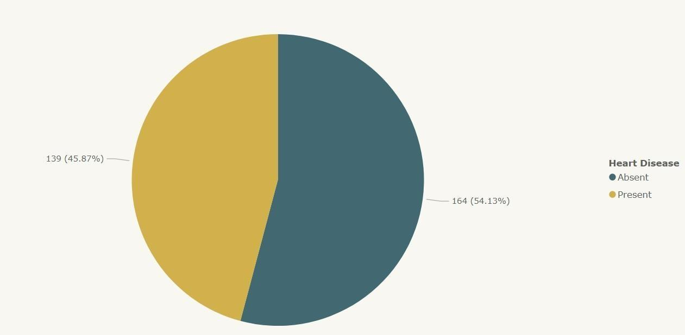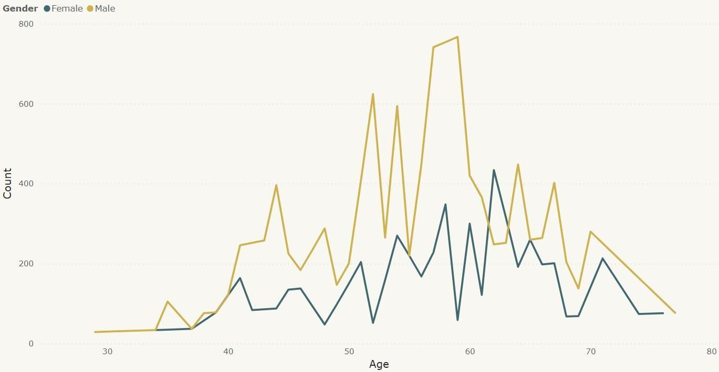

* + 45.87% People suffering from heart disease.
  + Elderly Aged Men are more (50 to 60 Years) and Females are more in 55 to 65 Years Category

# Who Suffer from Heart Disease?

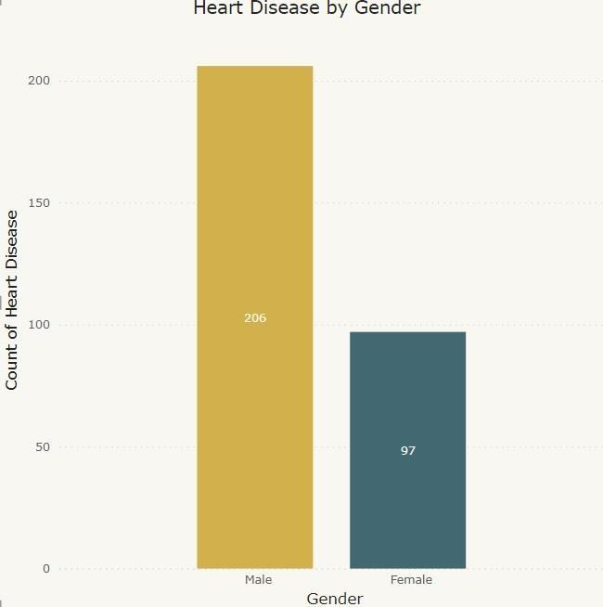

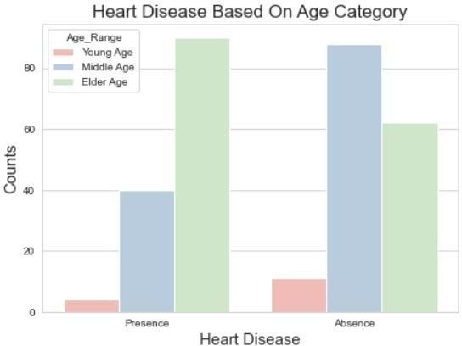

* + Males are more prone to heart disease.
  + Elderly Aged People are more prone to heart disease.

# What symptoms people experience in heart disease

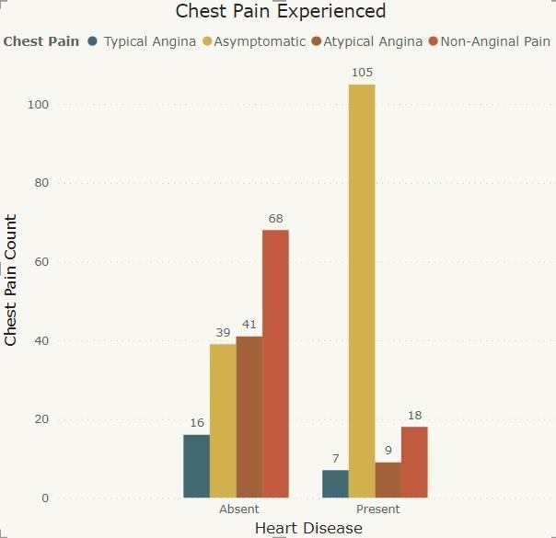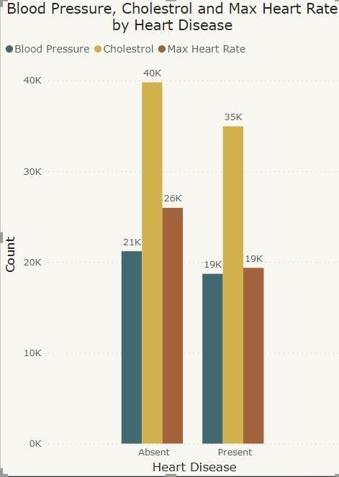

* + It seems people having asymptomatic chest pain have a higher chance of heart disease.
  + Asymptomatic Chest pain means neither causing nor exhibiting symptoms of heart disease.
  + It seems high number of cholesterol level in people having heart disease.

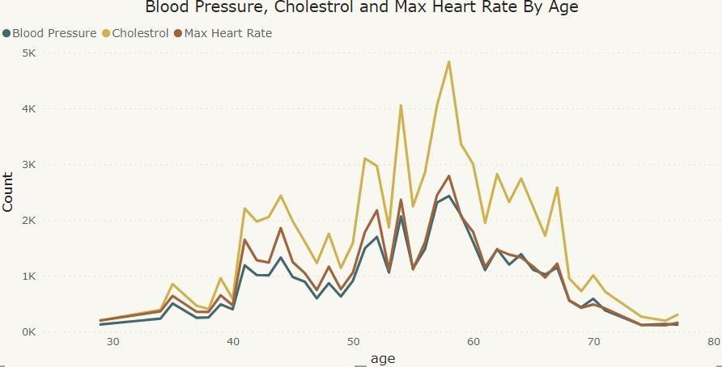

* + Here we can observe that Blood Pressure increases between age of 50 to 60 and somehow continue the pattern till 70.
  + Similarly, Cholesterol and maximum heart rate Increasing in the age group of 50-60.

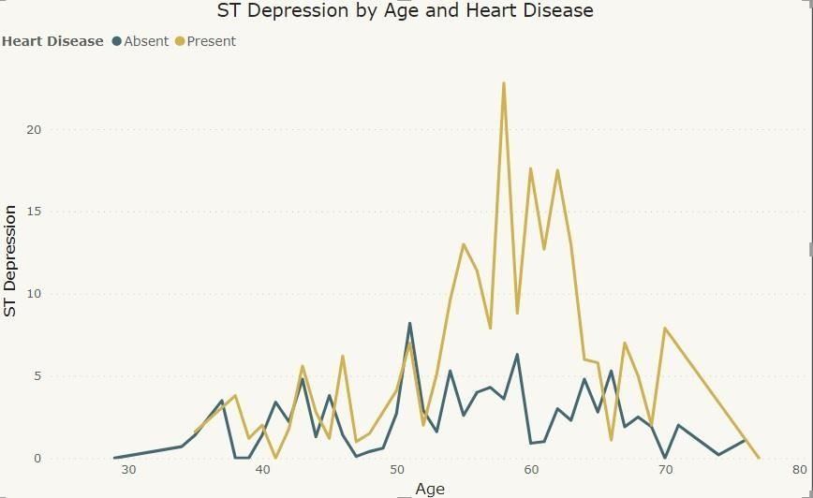

* + we can observe from here that ST depression mostly increases between the age group of 30-40.
  + ST depression refers to a finding on an electrocardiogram, wherein the trace in the ST segment is abnormally low below the baseline.